9415B 1:00 – 2:30 TF

iTutor

Andawi, Mark

Bayote, Rusell

Benitez, Jinci Clyde

Centino, Sarah Mae

Culbengan, Denver

De Guzman, Ryan Christian

Leonen, Aerhielle Cassandra

Macanlalay, Abigail

Madayag, Raoul

Suarez, Benedict

Tuyay, Jay Bryan

MODULE ACCOMPLISHMENT REPORT

1. Admin Module
   1. Platform: PHP
   2. Functionalities

|  |  |  |
| --- | --- | --- |
| Feature | Level of Functionality | Deficiencies |
| Log in | The administrator can log in to the module. |  |
| Search Function | Searches the registered service provider and customer. |  |
| Sort Function | Sorting of registered / unregistered members |  |
| Approval Function | Approves the members registration |  |
| Add Function | Adding of services |  |
| Delete Function | Deleting of the services |  |
| List Function | Able to list the registered customer and service provider |  |
| Log out | Logs out the admin to the module |  |

* 1. Screenshots

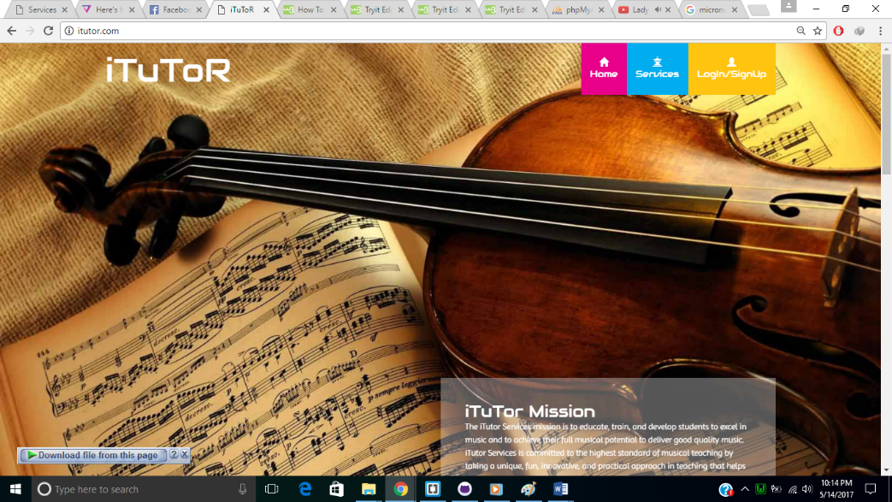

Figure 1. Public Face

*This is the main page of our website where visitor can view all about the iTuToR*.



Figure 1.1 Public Face

*In this is page of iTuTor the visitor can view the Services Offered.*

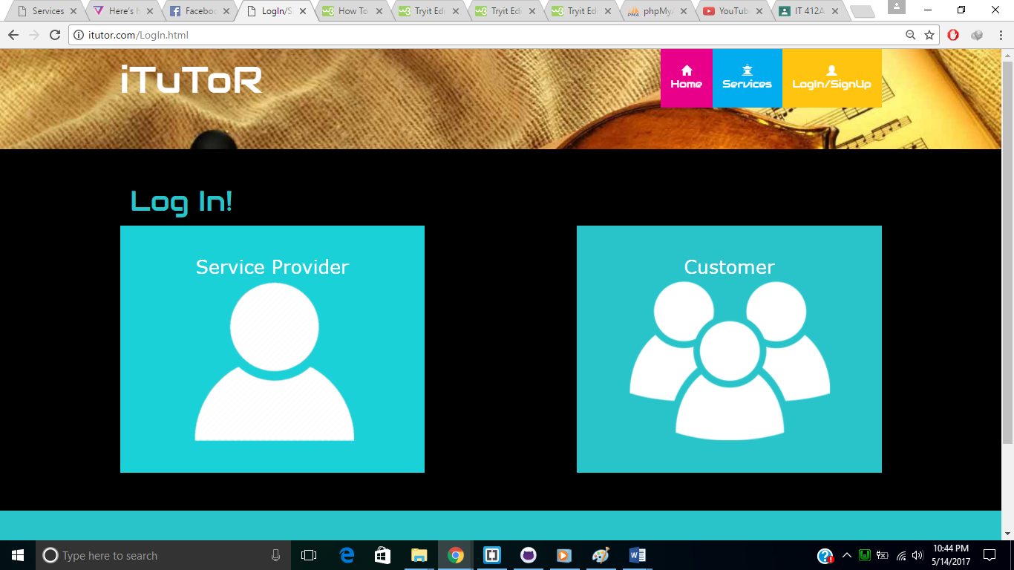

Figure 1.2 Public Face

*In this page of iTuToR the visitor or user can select to log in as a customer or service provider.*

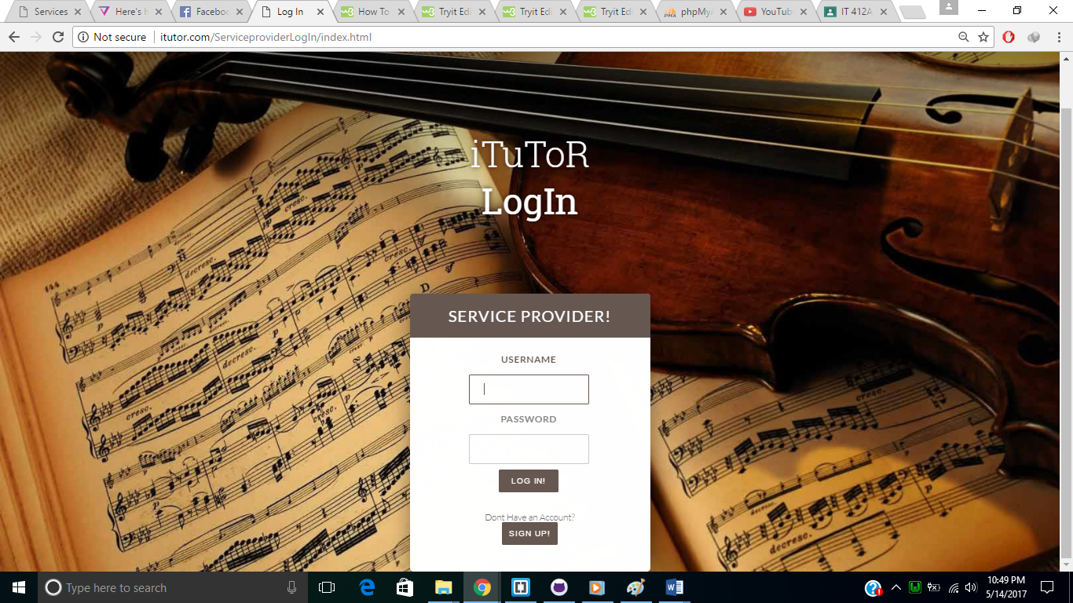

Fig 1.3 Public Face

*In this page of iTuTor the user can now log in.*

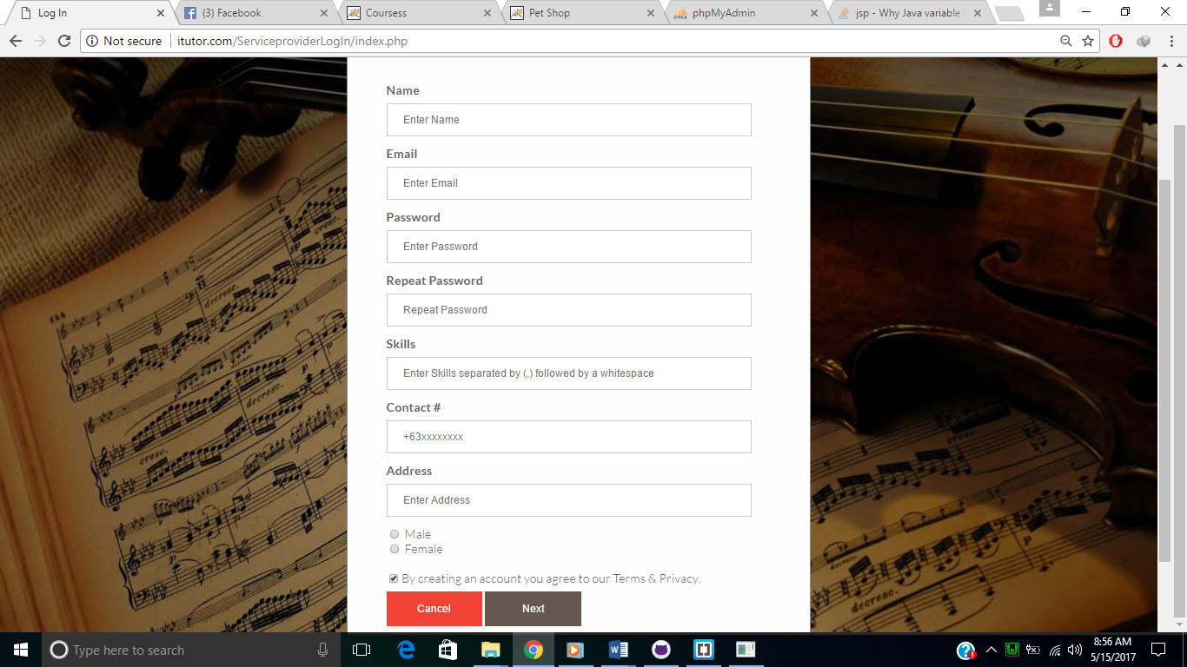

Fig 1.4 Public Sign Up

*In this page of iTuTor the user can now sign up to register.*



Fig 2 Admin Module

Log in page for administrator.

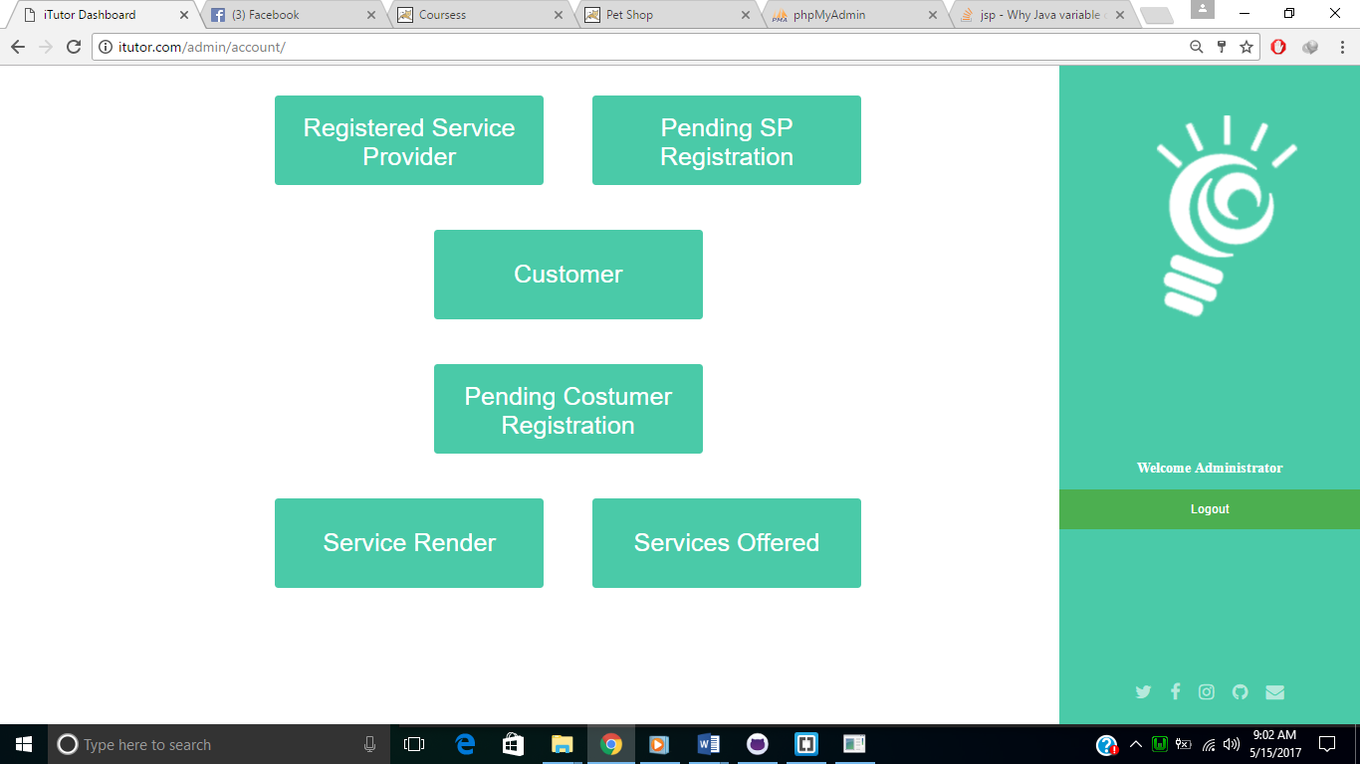

Fig 2 Admin Panel

Menus for Administrator

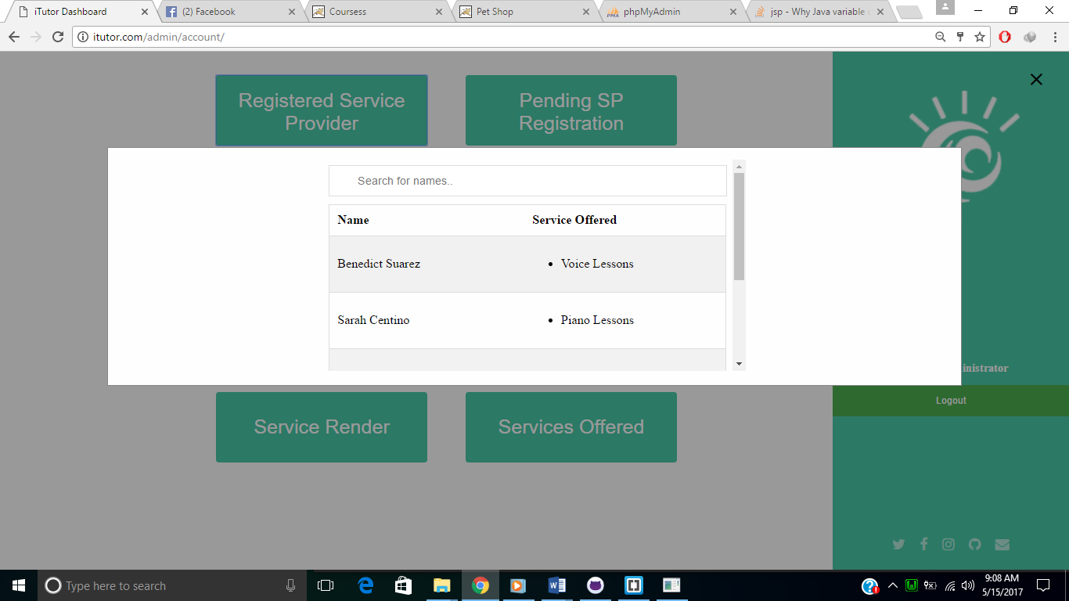

Fig 2.1 Registered Service Provider

View the list of current registered service providers

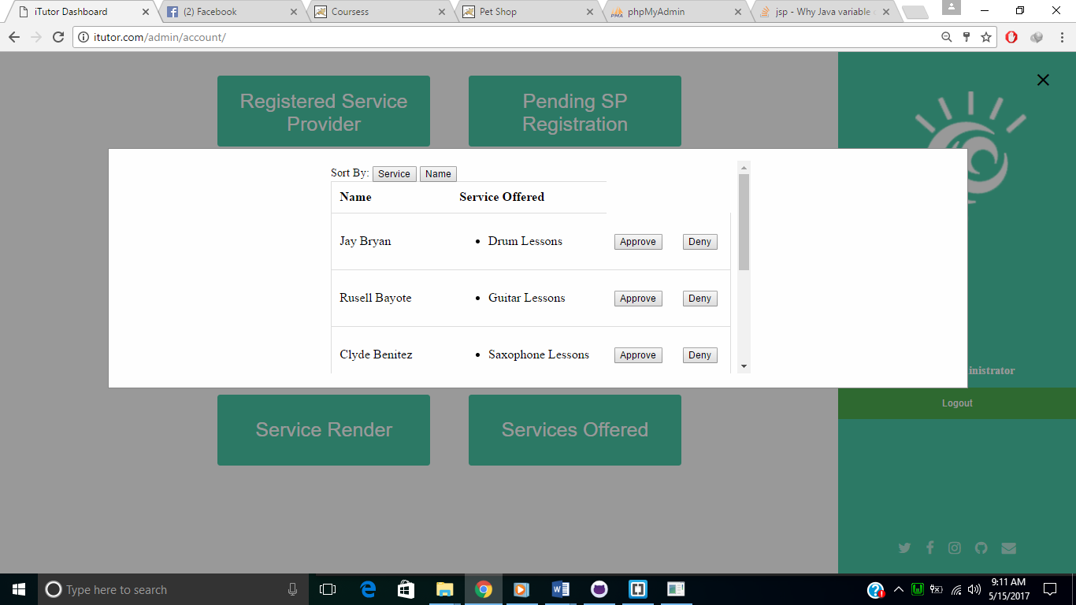

Fig 2.2 Pending SP Registration

In this module the admin can view the list of SP that is needed to be accept or deny can also sort the table.

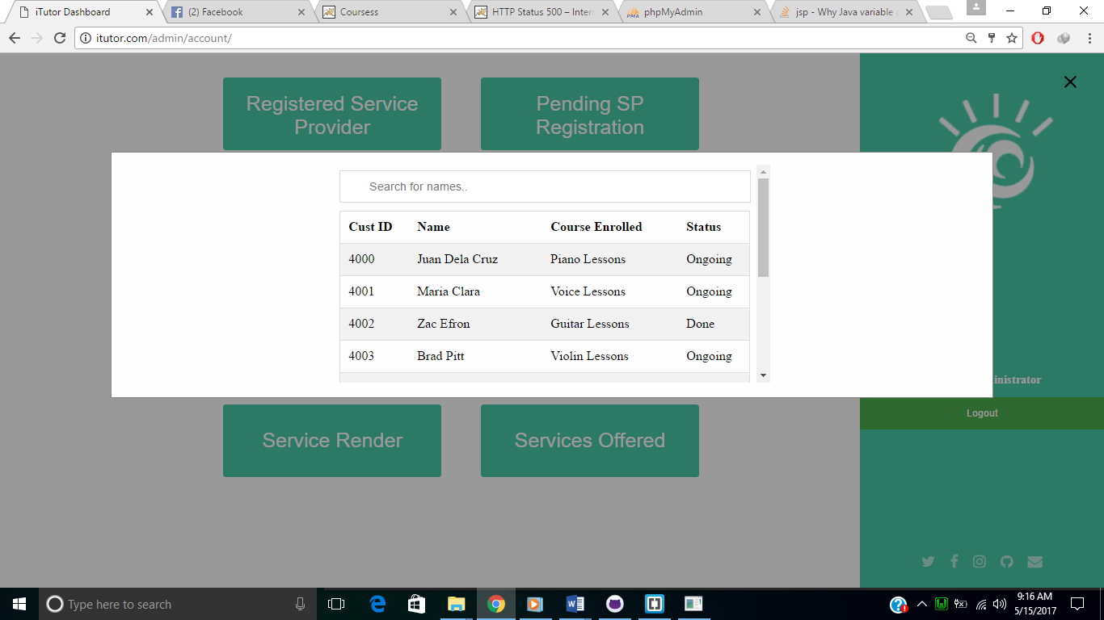

Fig 2.3 Customer

In this module the admin can view the list of customers

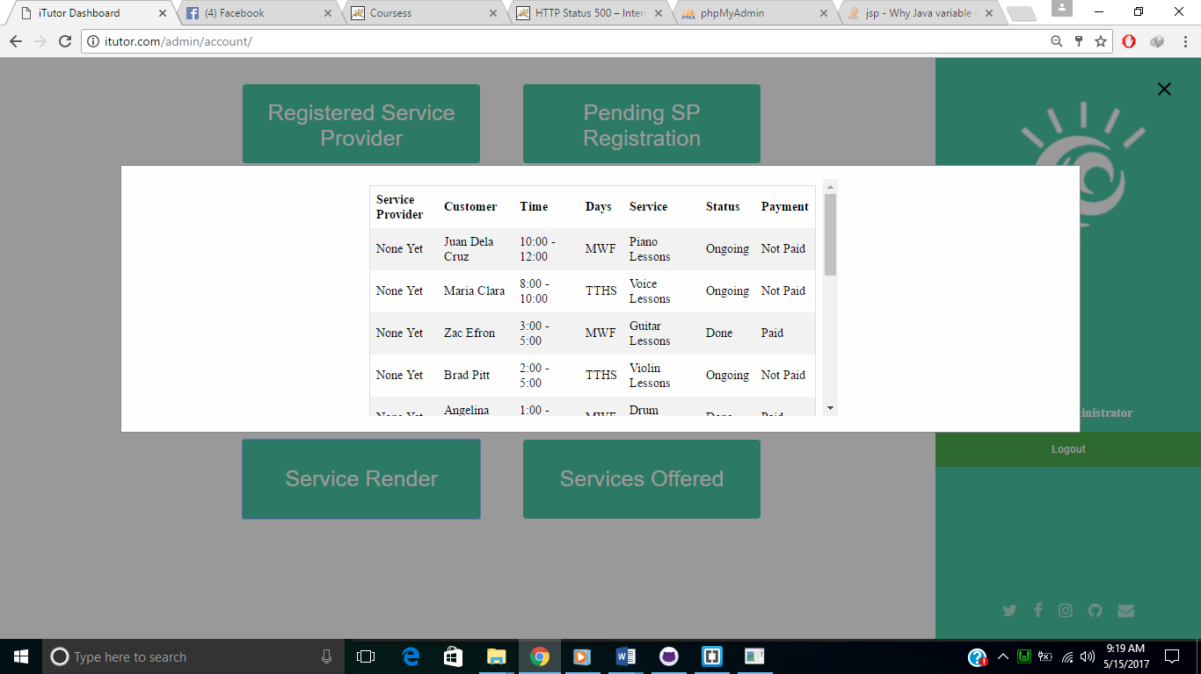

Fig 2.4 Service Rendered

In this module the admin can view the list of services that is rendered

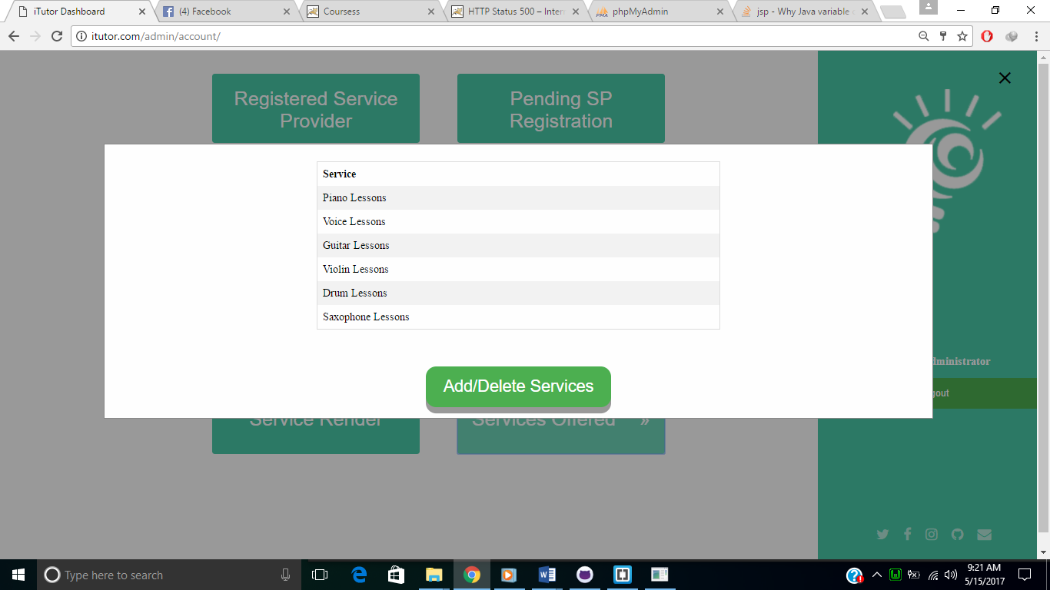

Fig 2.5 Services

In this module the admin can add / delete services and can view the list of services.

1. Service Provider Module
   1. Platform: Node.js
      1. Frameworks
         1. Express.js
      2. Extensions
         1. express
         2. mysql
         3. cookie-parser
         4. body-parser
   2. Functionalities

|  |  |  |
| --- | --- | --- |
| **Feature** | **Level of Functionality** | **Deficiencies** |
| Log-in | User’s log in page | Session handling |
| View Current Services | The application can show the service provider’s the view of his/her current services that he/she currently providing with a search and sort by function. |  |
| Update the current customer’s payment | The service provider can update to ‘Paid’ of his/her current customers by entering the request ID. | There is no validation in entering the request ID. |
| Update the current customer’s status of his/her service. | The service provider can update to ‘Done’ to the status of his/her current customers by entering the request ID. | There is no validation in entering the request ID. |
| View Service Requests | The application can show the service provider’s the view of his/her service requests with a search and sort by function. |  |
| Accept a service requests | The service provider can accept a service requests by entering the request ID. | There is no validation in entering the request ID. |
| View History | The application can show the service provider’s the view of his/her service histories with a search and sort by function. |  |
| Search | Under the table of the View Current Services, View Service Requests, and View History the SP can search customer’s name under those table. |  |
| Sorting | Under the table of View Current Services, View Services Requests, and View History the SP can sort all the columns that are needed to be sorted by ascending order. | Can’t sort by descending order. |
| View Profile | The SP can view his/her profile. | Can’t edit his/her profile. |
| Edit Profile | The page where the SP can edit his/her profile. | But can’t update into the database. |
| Log-out | Log-out session of the SP | Session handling |

* 1. Screenshots

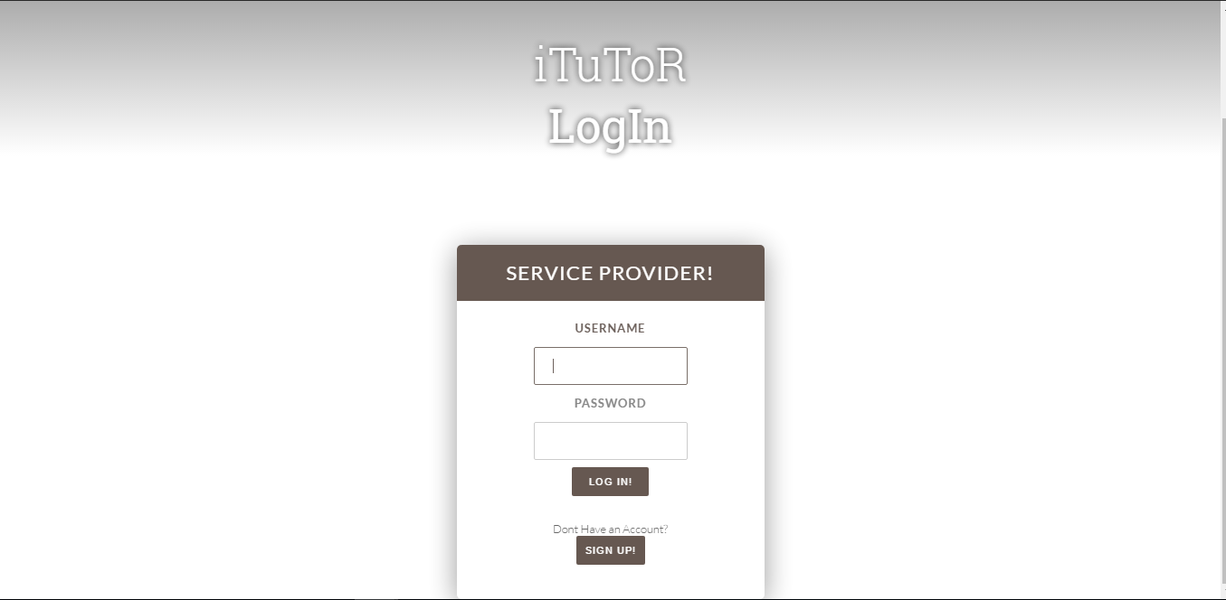

Figure 1. Log-in

*The page where the SP can log-in.*

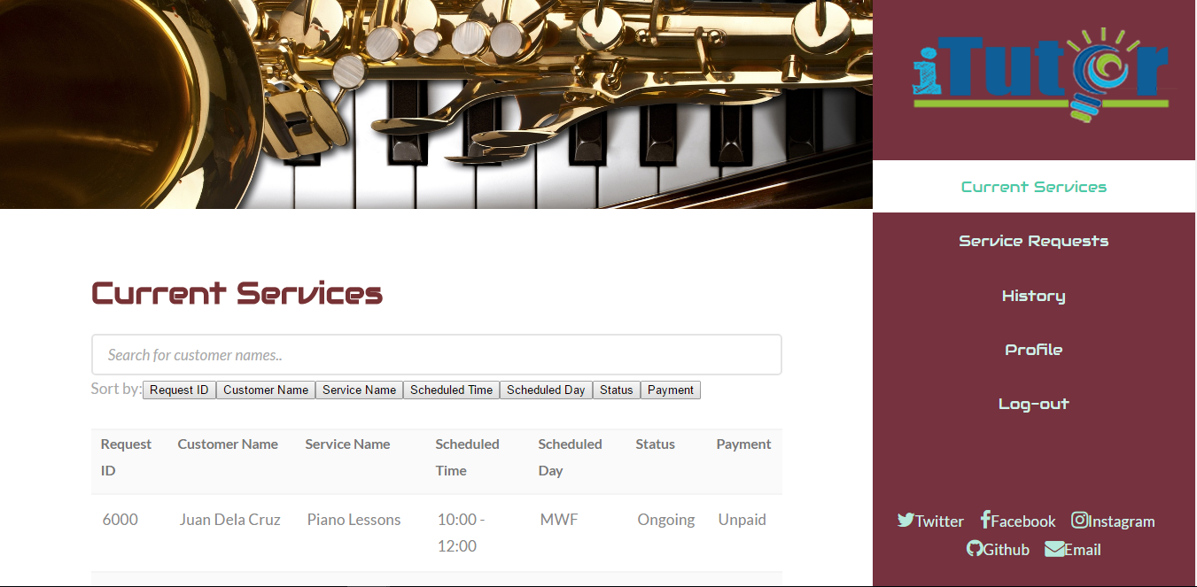

Figure 2. Current Services

*The page where the service provider views his/her current services including the search customer names and sort the columns functionality.*

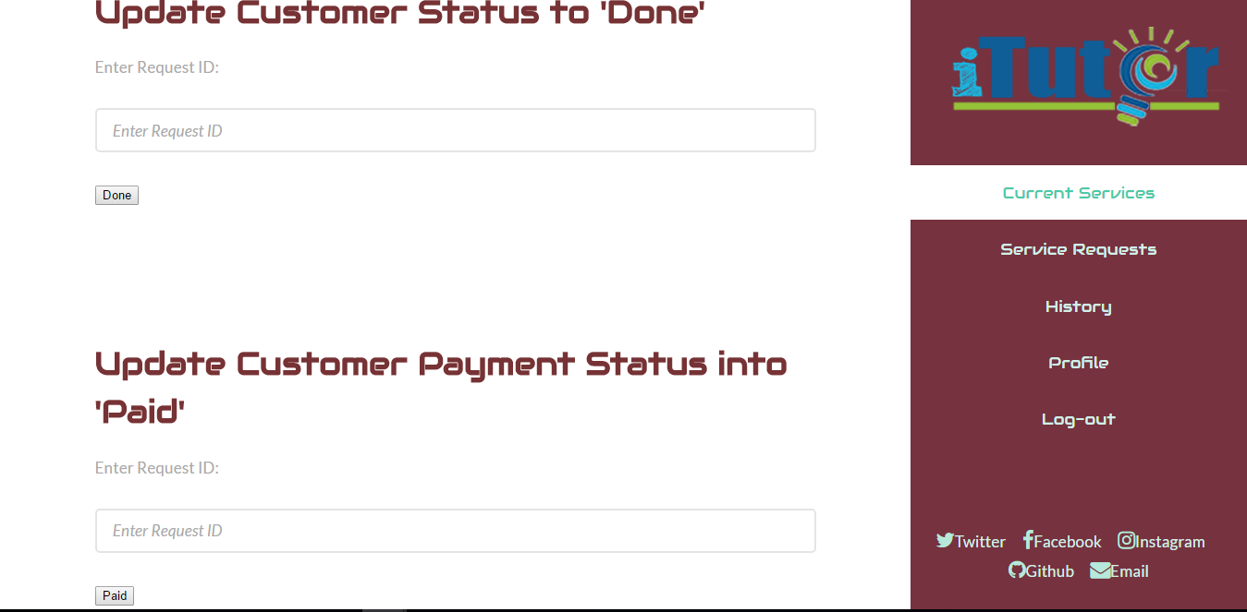

Figure 3. Current Services – Update Customer Status to ‘Done’ and ‘Update Customer Payment Status into ‘Paid’

*The page from the current services where the service provider can update customer status to ‘done’ and payment status to ‘paid’.*

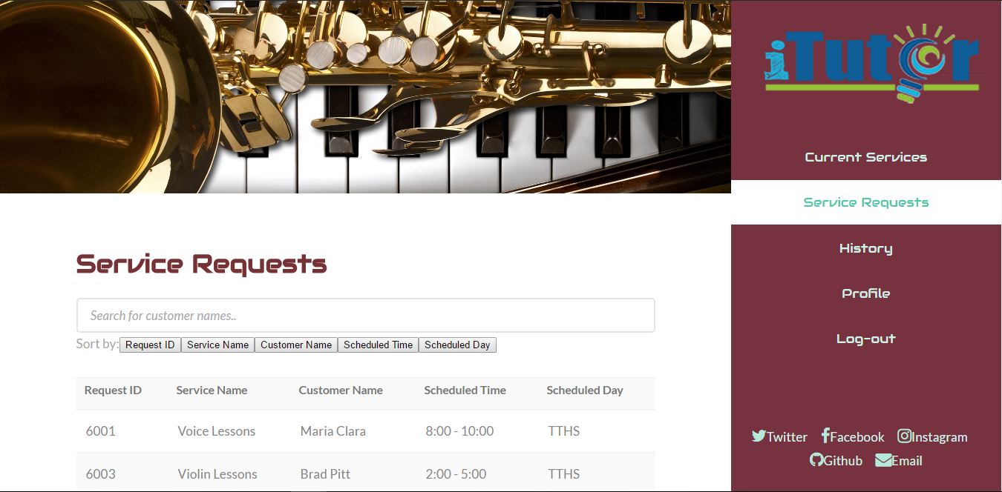

Figure 4. Service Requests

*The page where the service provider views his/her service requests. He can also accept services with search functionality and sort functionality.*

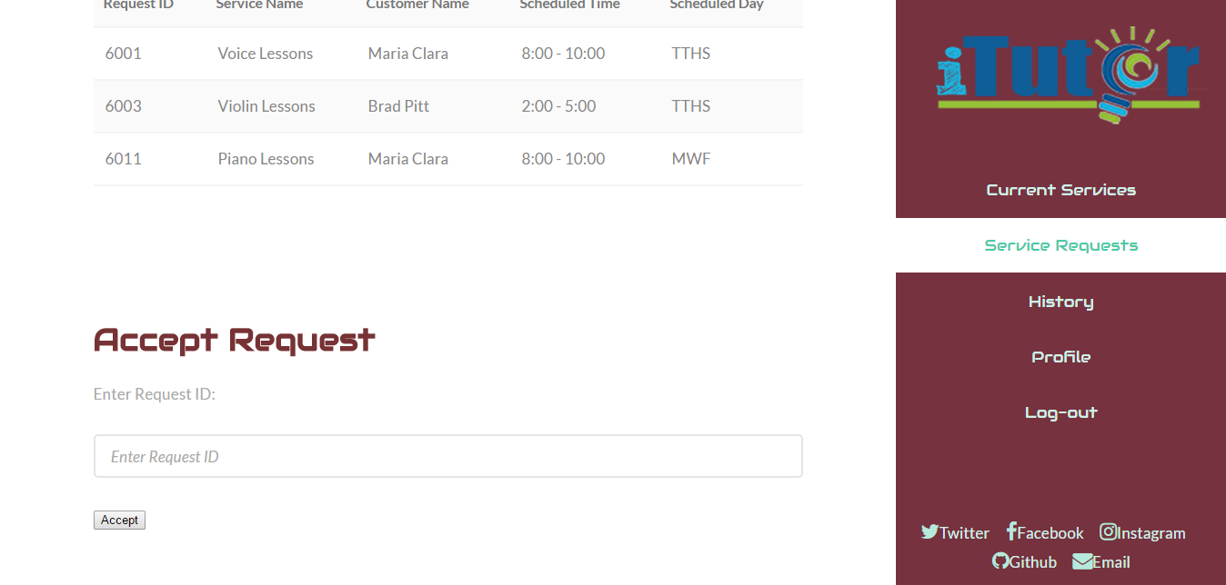

Figure 5. Service Requests – Accept Request

*The page where the service provider can accept request by entering the request ID.*

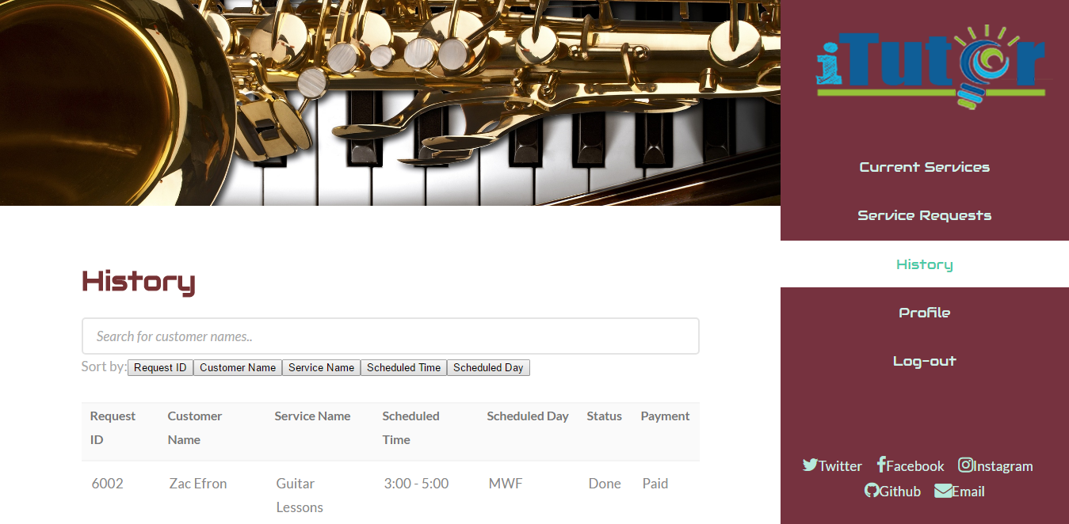

Figure 6. History

*The page where the service provider can view his/her past customers that he/she served with search and sort by functionality.*



Figure 7. View Profile

*The page where the service provider can view his/her profile information.*



Figure 8. Edit Profile

*The page where the service provider can edit his/her profile information.*

III. Client Module

**Platform: JSP**

|  |  |  |
| --- | --- | --- |
| **Feature** | **Level of Functionality** | **Deficiencies** |
| Log in | The customer can login | Validation is also in JSP |
| Search Function | Enables customer to search for services |  |
| Sort Function | Supports sorting of services or scheduled date and time |  |
| View Services | Enables customer to view requested, ongoing, or finished classes | Same output in all customers |
| Enroll Class | Enables user to choose a service and specify schedule for the service provider to approve |  |
| Log out | Logs out the customer to the module |  |

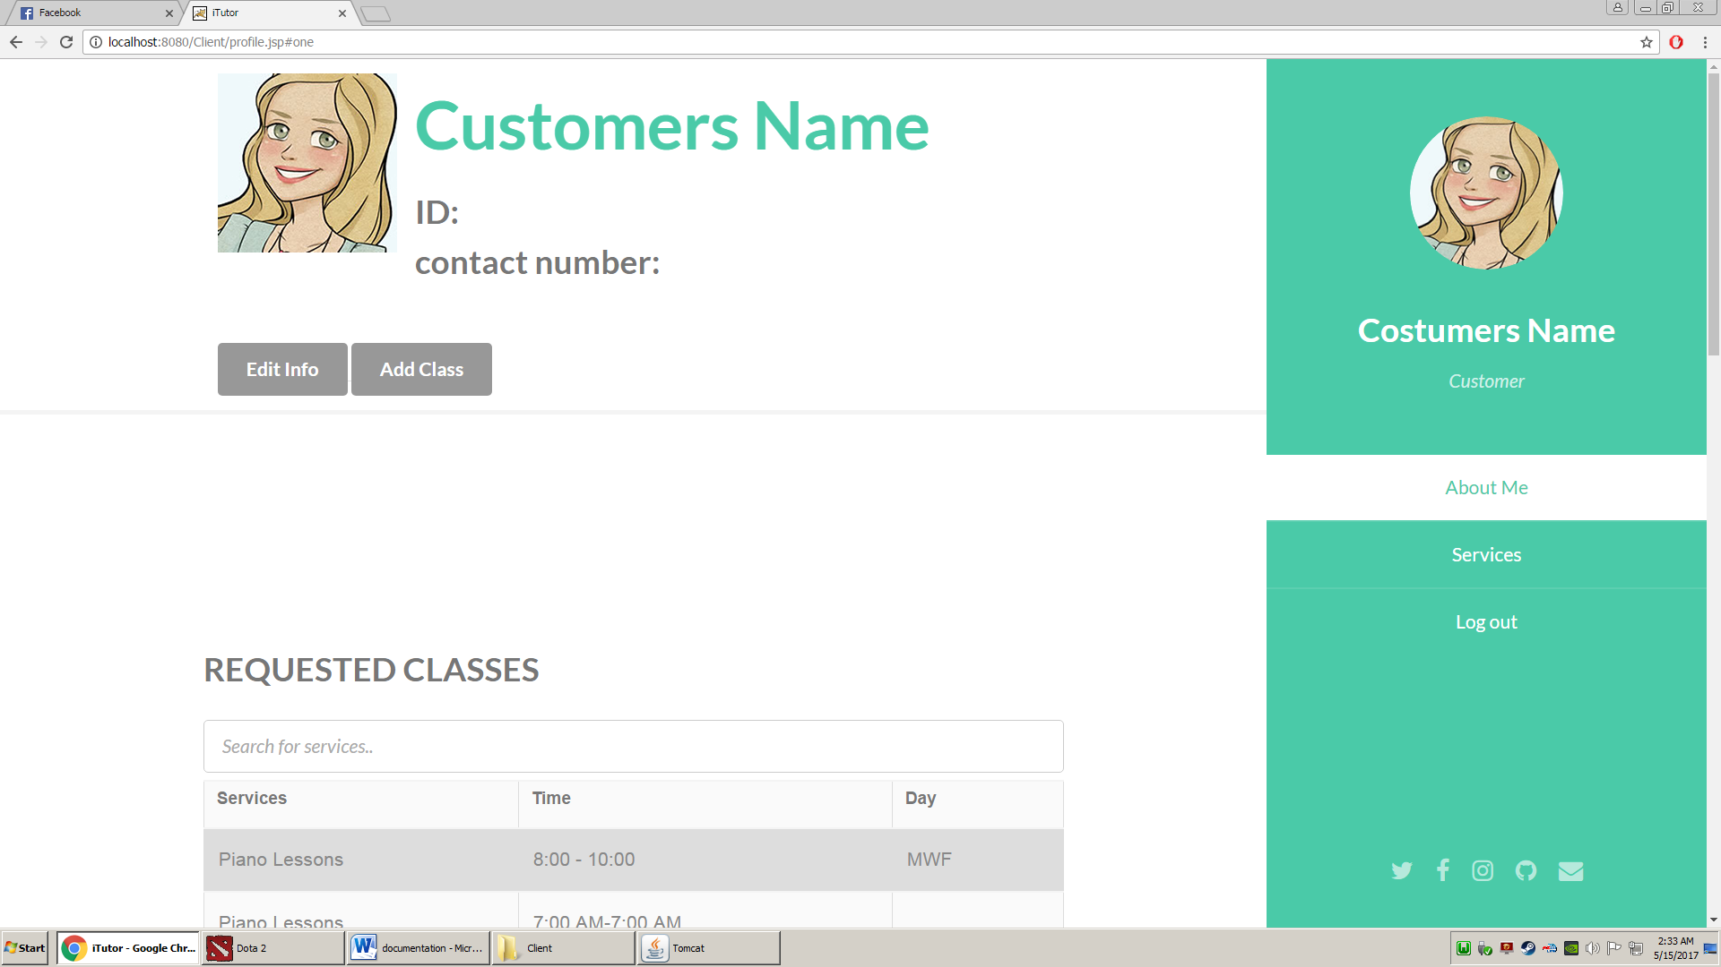

Fig2. Costumer after log-in

The first thing you see after logging-in

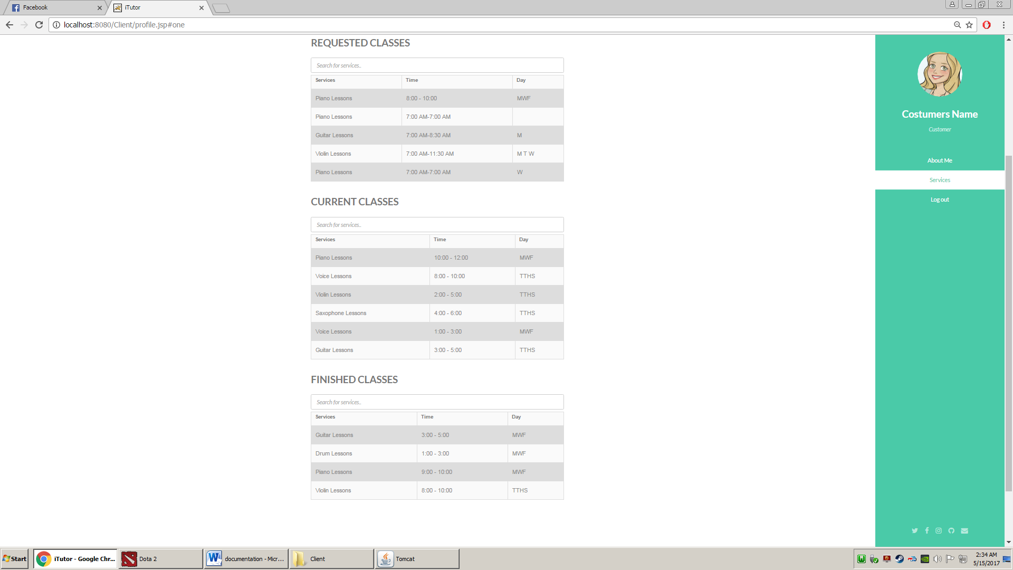

Fig2.1. Costumer can view his

requested, current, and finished classes

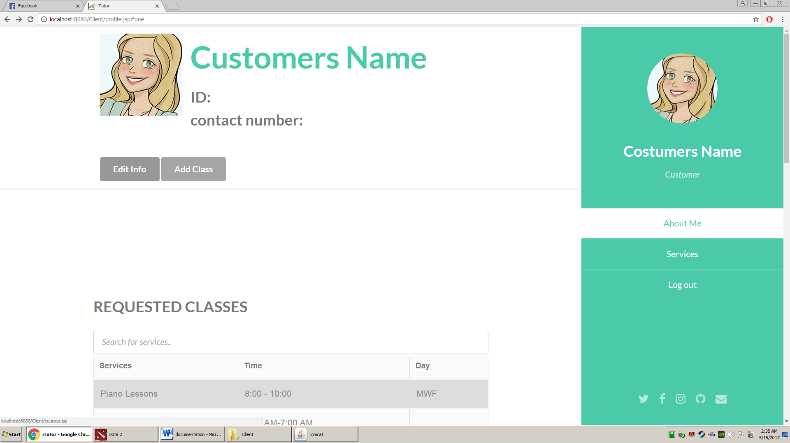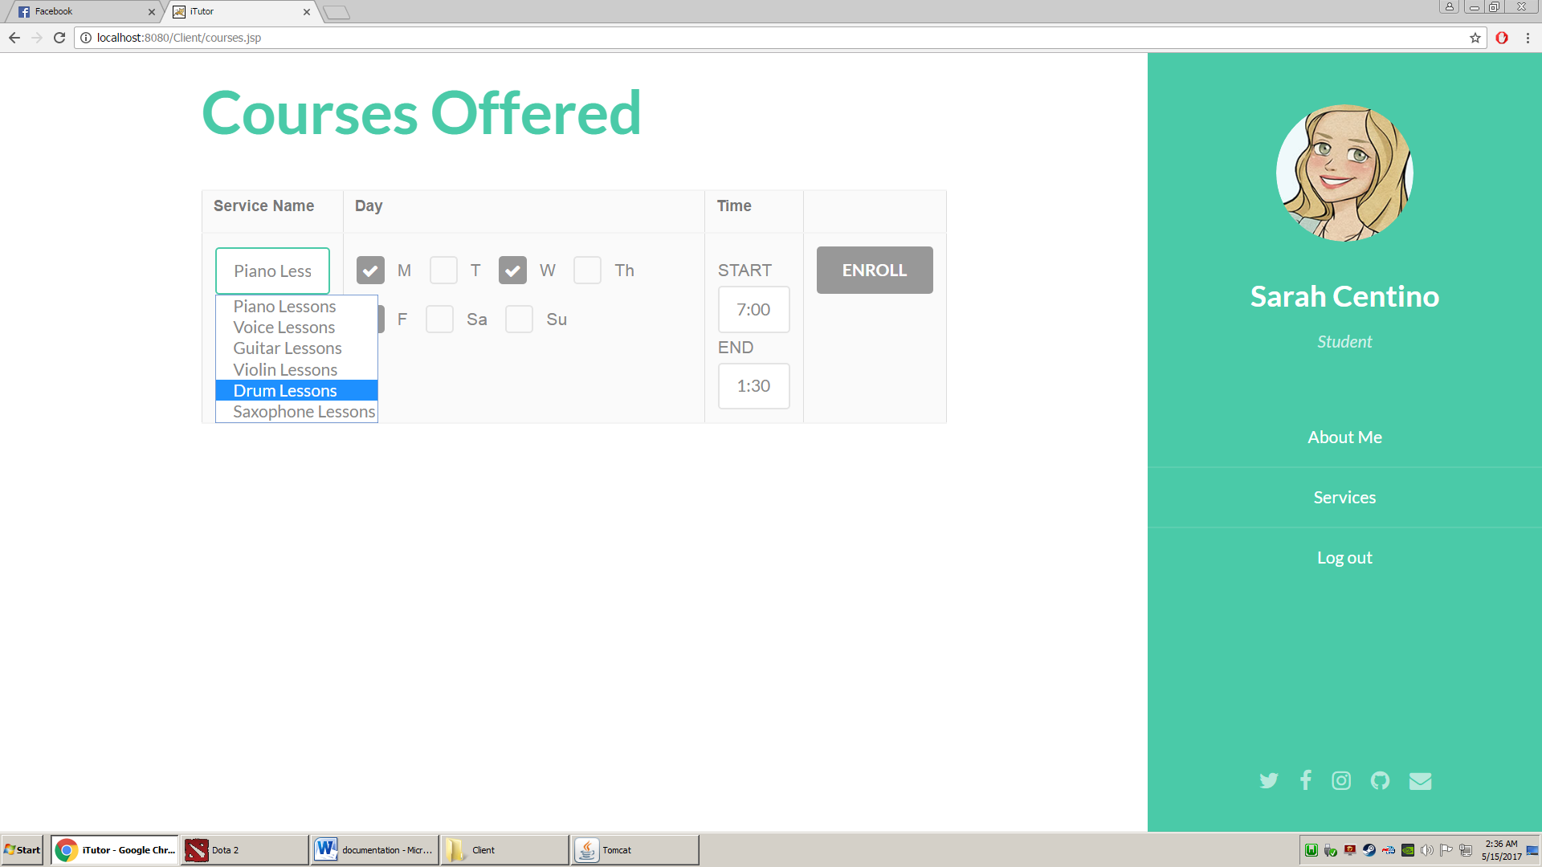

Fig2.2. Customer can enrol a class by pressing add class then choosing the schedule he/she wants.

MEMBER ACCOMPLISHMENT REPORT

|  |  |  |  |
| --- | --- | --- | --- |
| **Member** | **Accomplishments** | **%Contributions** | **Signature** |
| Andawi, Mark |  |  |  |
| Bayote, Rusell |  |  |  |
| Benitez, Jinci Clyde |  |  |  |
| Centino, Sarah Mae |  |  |  |
| Culbengan, Denver |  |  |  |
| De Guzman, Ryan Christian |  |  |  |
| Leonen, Aerhielle Cassandra |  |  |  |
| Macanlalay, Abigail |  |  |  |
| Madayag, Raoul |  |  |  |
| Suarez, Benedict |  |  |  |
| Tuyay, Jay Bryan |  |  |  |